**Assignment : DNS**

**Computer Networking**

**Tanmay Dureja (td1391)**

1. Config files: Forward and Reverse for R1 and Kali

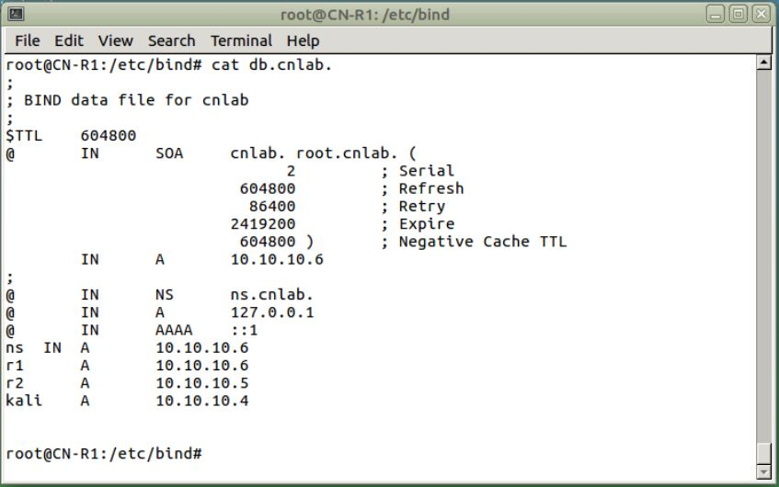

Capture Bind Data File for Zone 1

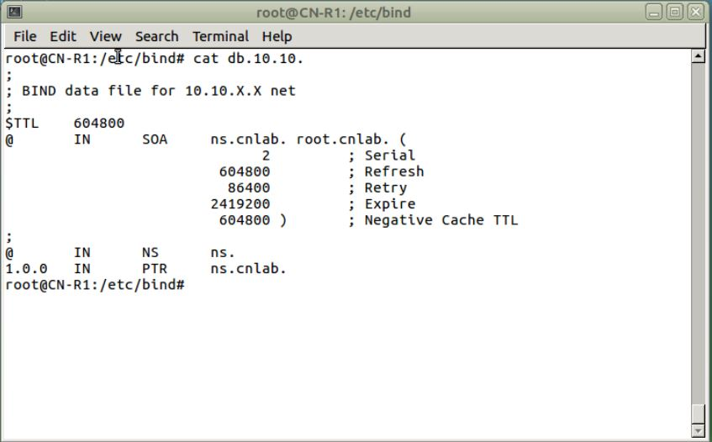

Capture Reverse Bind Data File for Zone 1

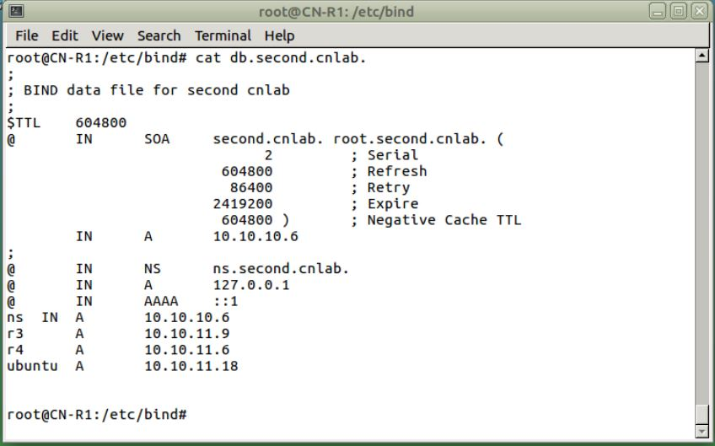

Capture Bind Data File for Zone 2

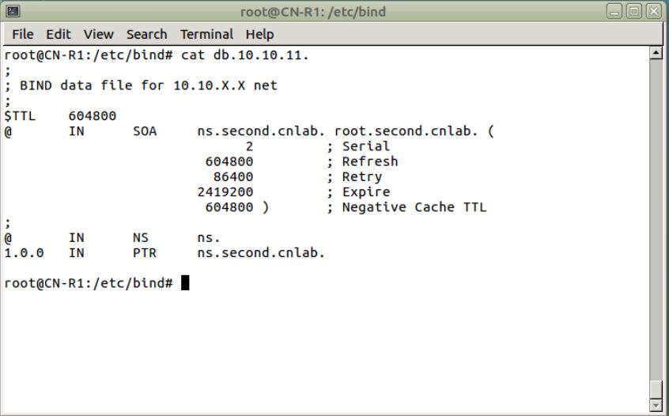

Capture Reverse Bind Data File for Zone 2

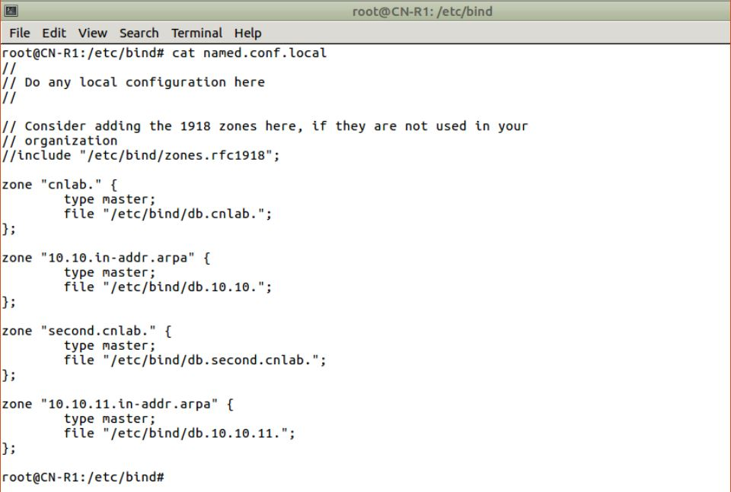

Capture Named.conf.local File

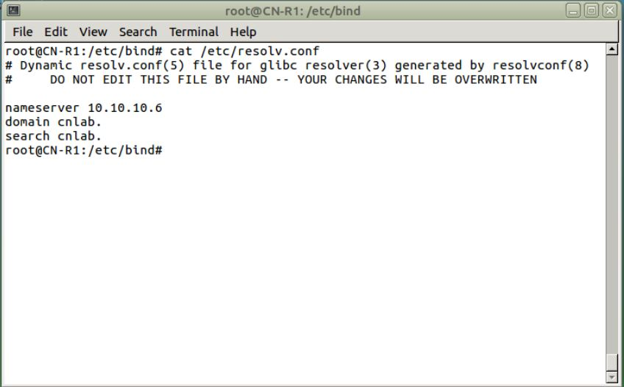

Capture resolv.conf R1

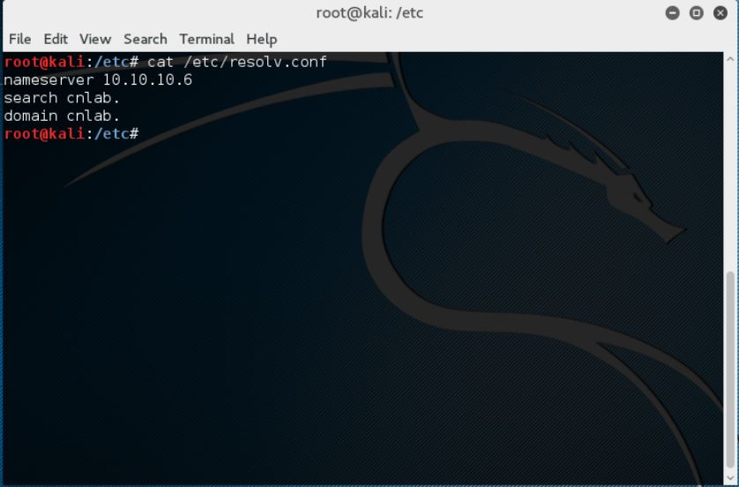

Capture Resolv.conf Kali

1. Ping by Name

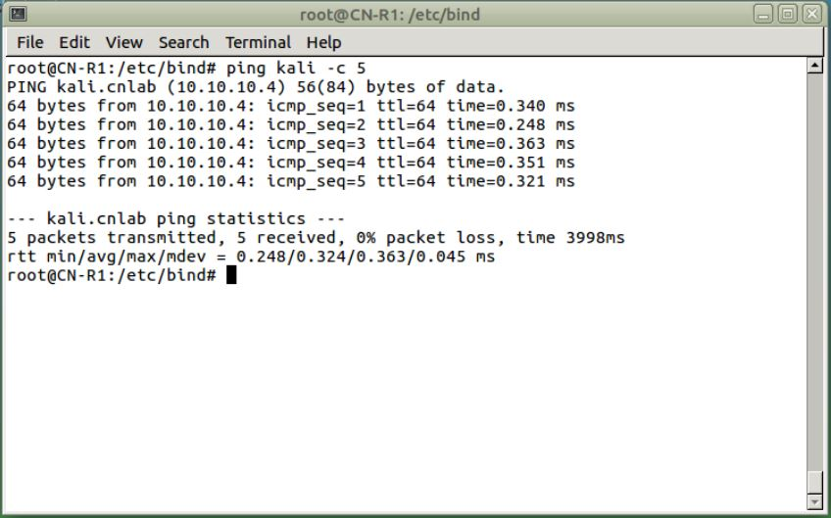

Capture R1 Ping to Kali

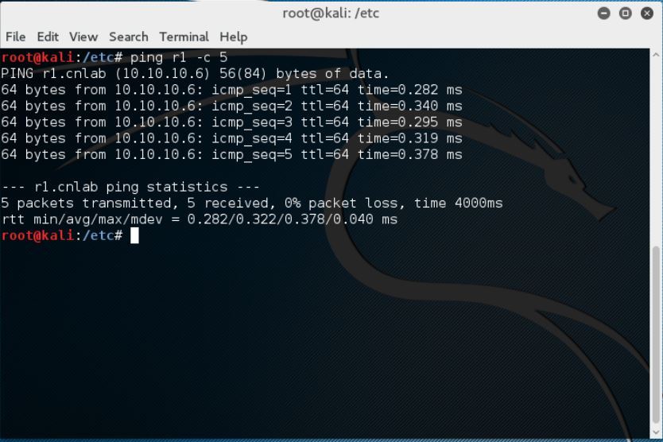

Capture Kali ping R1